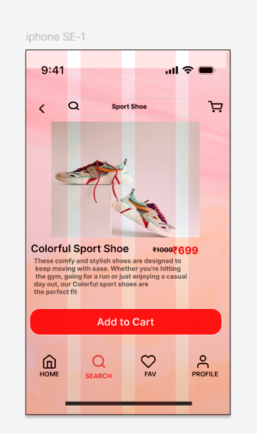 Design part for ecommerce app using figma

If user press Add to cart button then successfully added will appear on screen

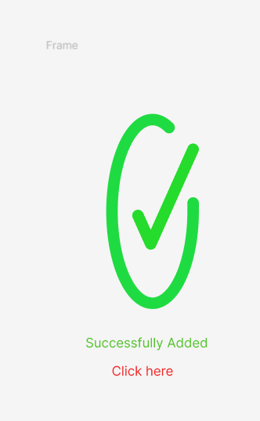

This frame responsible for removing the item

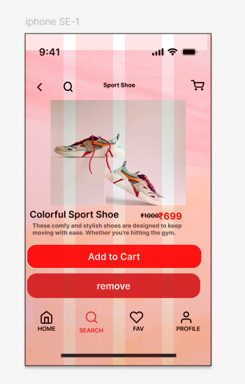

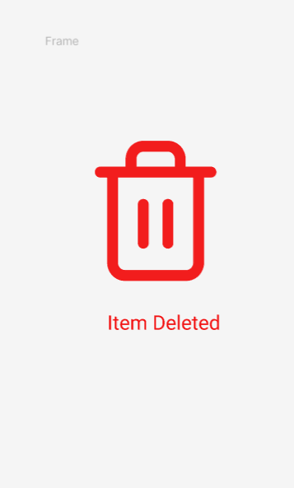after pressing remove button . the item will be deleted